# Flowchart

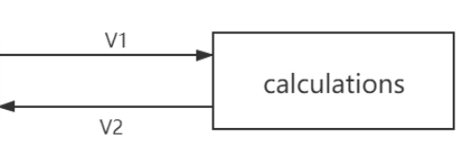

Figure Calculation subsystem flowchart

# Table of limits

|  |  |  |  |  |
| --- | --- | --- | --- | --- |
| Interaction | Symbol | Min. | Max. | Unit |
| -> V1 | | | | |
| Data from user interface sub-system | | | | |
| Limit input | | | | |
| Motor input voltage | $$V_{input}$$ | 0 | 48 | V |
| Properities input (used to set up calculation) | | | | |
| Bearing friction coefficient | $$µ_{bear}$$ | $$0,8*{10}^{-3}$$ | $$2,5*{10}^{-3}$$ | - |
| Gear friction coefficient | $$µ_{gear}$$ | *0.1* | *0.15* | - |
| Gear transmission ratio | $$R_{g}$$ | 0,1 | 10 | # |
| Gear index circle pressure angle | $$α$$ | 15 | 25 | $$°$$ |
| Gear index circle diameter of driving wheel | $$d$$ | 0 | - | m |
| Gear addendum radius | $$d_{1}$$ | 0 | **-** | m |
| Gear deddendum radius | $$d_{2}$$ | 0 | - | m |
| Tooth number | $$z$$ | 0 | **-** | **-** |
| Modulus | $$m$$ | 0 | - | - |
| Immersion depth | $$h$$ | 0 | R | m |
| Tooth width | $$b$$ | 0 | R | m |
| Lubricant viscosity | $$μ$$ | **0** | **-** | **-** |
| Lubricant density | $$ρ$$ | 0 | - | $${kg}/{m^{3}}$$ |
| Propeller blade count | - | 2 | 6 | # |
| Propeller diameter | $$d_{prop}$$ | 0,1 | 0,5 | m |
| Torque | $$T_{prop}$$ | 5 | 30 | Nm |
| Blade coefficient | $$µ_{blade}$$ | 0 | 1,2 | - |
| Blade pitch | - | 35 | 39 | ° |
| Propeller coefficient | $$K_{T}$$ | 0 | 0,4 |  |
| J | 0 | 0,9 |  |
| Motor characteristic data array | - | - | - | V, P, T, rpm |
| -> V2 | | | | |
| Data to user interface sub-system | | | | |
| Limit output | | | | |
| Thrust | $$F_{T}$$ | 0 | 500 | N |
| Rotational speed propeller | $$ϖ_{P}$$ | 0 | 2300 | rpm |
| Power input | $$P_{input}$$ | 0 | 9700 | W |
| Power output | $$P_{output}$$ | 0 | 8500 | W |
| Power loss | $$P_{loss}$$ | 0 | 8500 | W |
| Efficiency | $$η$$ | 0 | 100 | % |

Tip: The range of power input comes from the motor T-N curve provided by the company.